LAB -1

IMPLEMENTATION OF BASIC GATES USING VHDL

Introduction

VHDL(VHSIC Hardware Description Language ) is a hardware description language used in electronic design automation to describe digital and mixed signal system such as fixed programmable gate arrays and integrated circuits VHDL can be used as general purpose parallel programming language.

Levels of representation and abstraction

A digital system can be represented at different levels of abstraction this keeps the description and design of complex system manageable.

Behavioral

The highest level of abstraction that describes a system in terms of what it does (or how it behaves) rather than in terms of its components and interconnection between them.

Structural

The structural level describes a system as a collection of gates and components that are interconnected to perform a desired function.

Basic structure of VHDL file

A digital system in VHDL consist of a design entity that can contain other entities that are then considered components of top level entity.

Each entity is modelled by an architecture body.

#### Different logic gates

AND Gate

The AND gate is a [digital logic gate](https://www.elprocus.com/different-types-of-digital-logic-circuits/) with ‘n’ i/ps one o/p, which performs logical conjunction based on the combinations of its inputs. The output of this gate is true only when all the inputs are true.

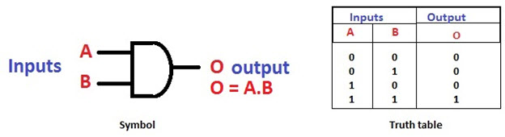

#### OR Gate

The OR gate is a digital logic gate with ‘n’ i/ps and one o/p, that performs logical conjunction based on the combinations of its inputs. The output of the OR gate is true only when one or more inputs are true.

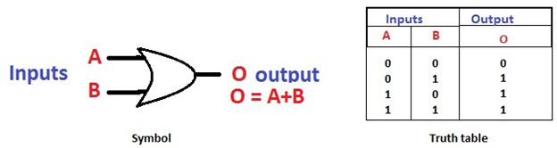

#### 

#### NOT Gate

The NOT gate is a digital logic gate with one input and one output that operates an inverter operation of the input. The output of the NOT gate is the reverse of the input.

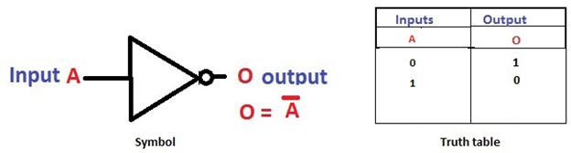

#### NAND Gate

The NAND gate is a digital logic gate with ‘n’ i/ps and one o/p, that performs the operation of the AND gate followed by the operation of the NOT gate.NAND gate is designed by combining the AND and NOT gates.

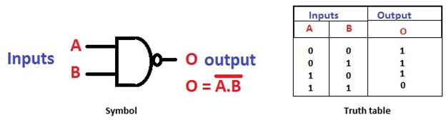

#### NOR Gate

The NOR gate is a digital logic gate with n inputs and one output, that performs the operation of the OR gate followed by the NOT gate. NOR gate is designed by combining the OR and NOT gate.

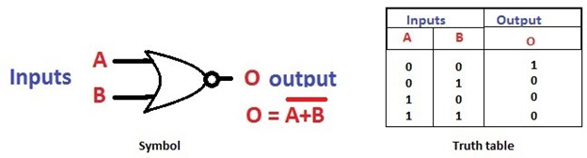

#### Exclusive-OR Gate

The Exclusive-OR gate is a digital logic gate with two inputs and one output. The short form of this gate is Ex-OR. It performs based on the operation of the OR gate.

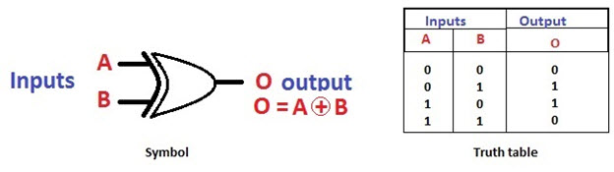

#### Exclusive-NOR Gate

The Exclusive-NOR gate is a digital logic gate with two inputs and one output. The short form of this gate is Ex-NOR. It performs based on the operation of the NOR gate.

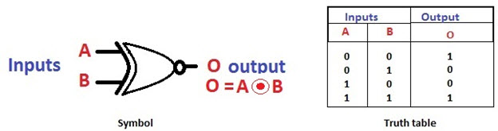

Half adder

So, coming to the scenario of half adder, it adds two binary digits where the input bits are termed as augend and addend and the result will be two outputs one is the sum and the other is carry. To perform the sum operation, XOR is applied to both the inputs, and AND gate is applied to both inputs to produce carry.

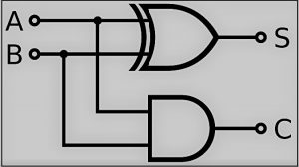

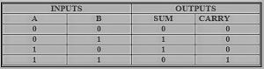

Full adder

The difference between a half-adder and a full-adder is that the full-adder has three inputs and two outputs, whereas half adder has only two inputs and two outputs.

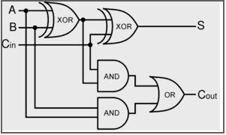

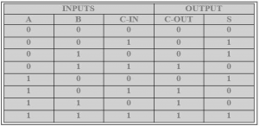

Entity ha is

Port (a: in  STD_LOGIC;  
b : in  STD_LOGIC;  
sha : out  STD_LOGIC;  
cha : out  STD_LOGIC);  
end ha;

Architecture Behavioral of the above circuit is

begin  
sha <= a xor b ;  
cha <= a and b ;  
end Behavioral

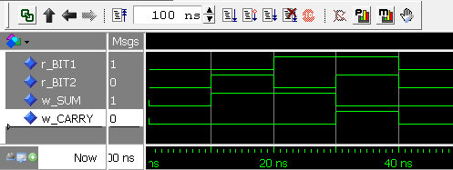

Discussion and conclusion

In this lab we viewed different logic gates and half adder and full adder behavioural model in VHDL programming.